**Databases**

**Hospital Management System - DB**

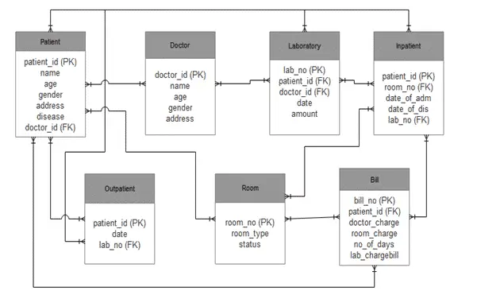

**Hospital-Management-System – DB**

**Tables**

**Patient**

|  |  |  |
| --- | --- | --- |
| **FieldName** | **DataType** | **Constraints** |
| PatientID | varchar(15) | Primary Key |
| PatientName | varchar(40) | Not Null |
| Age | int | Not Null |
| Gender | varchar(15) | Not Null |
| Address | varchar(100) | Not Null |
| ContactNo | bigint | Not Null |
| GardianName | varchar(40) |  |
| Disease | varchar(100) | Not Null |
| DoctorID | Int | Foreign Key |
| CreatedDate | DateTime | Not Null, Default |
| CreatedUser | varchar(40) | Not Null |
| DateModified | DateTime | Not Null, Default |
| ModifiedUser | varchar(40) | Not Null |
| Status | Bit/int | Not Null |

**Doctor**

|  |  |  |
| --- | --- | --- |
| **Field Name** | **Data Type** | **Constraints** |
| DoctorID | Int | Primary Key |
| DoctorName | Varchar(40) | Not Null |
| Age | Int | Not Null |
| Gender | Varchar(15) | Not Null |
| Address | Varchar(100) | Not Null |
| ContactNo | Bigint | Not Null |
| Qualification | Varchar(50) | Not Null |
| Specialization | Varchar(50) | Not Null |
| VisitingDays | Varchar(50) | Not Null |
| VisitingHrs | Varchar(50) | Not Null |
| CreatedDate | DateTime | Not Null, Default |
| CreatedUser | Varchar(40) | Not Null |
| ModifiedDate | DateTime | Not Null, Default |
| ModifiedUser | Varchar(40) | Not Null |
| Status | int | Not Null |

**Room**

|  |  |  |
| --- | --- | --- |
| **Field Name** | **Data Type** | **Constraints** |
| RoomNo | Int | Primary Key |
| BlockName | Varchar(30) | Not Null |
| RoomType | Varchar(30) | Not Null |
| Rent | Int | Not Null |
| Availability | Char(2) | Not Null |

**Laboratory**

|  |  |  |
| --- | --- | --- |
| **Field Name** | **Data Type** | **Constraints** |
| LabReferenceNo | Int | Primary Key |
| PatientID | Varchar(15) | Foreig Key |
| DoctorID | Int | Foreign Key |
| IPReferenceNo | Int | Foreign Key |
| TestDate | DateTime | Not Null |
| InchargeName | Varchar(40) | Not Null |
| CreatedDate | DateTime | Not Null, Default |
| CreatedUser | Varchar(40) | Not Null |
| ModifiedDate | DateTime | Not Null, Default |
| ModifiedUser | Varchar(40) | Not Null |

**OutPatient**

|  |  |  |
| --- | --- | --- |
| **Field Name** | **Data Type** | **Constraints** |
| OPReferenceNo | Int | Primary Key |
| PatientID | varchar(15) | Foreign Key |
| DoctorID | Int | Foreign Key |
| VisitDate | DateTime | Not Null, Default |
| Complaint | Varchar(100) | Not Null |
| Diagnosis | Varchar(100) | Not Null |
| Treatment | Varchar(100) | Not Null |
| CreatedDate | DateTime | Not Null, Default |
| CreatedUser | Varchar(40) | Not Null |
| ModifiedDate | DateTime | Not Null, Default |
| ModifiedUser | Varchar(40) | Not Null |
| Status | Varchar(10) | Not Null |
| Status | Int | Not null |

**Inpatient**

|  |  |  |
| --- | --- | --- |
| **Field Name** | **Data Type** | **Constraints** |
| IPReferenceNo | Int | Primary Key |
| PatientID | Varchar(15) | Foreign Key |
| RoomNo | Int | Foreign Key |
| AdmissionDate | DateTime | Not Null, Default |
| DoctorIncharge | Int | Foreign Key |
| DischargeDate | DateTime | Null |
| Status | Varchar(20) | Not Null |
| Remark | Varchar(100) | Null |
| CreatedDate | DateTime | Not Null, Default |
| CreatedUser | Varchar(40) | Not Null |
| ModifiedDate | DateTime | Not Null, Default |
| ModifiedUser | Varchar(40) | Not Null |
| Status | Int | Not Null |

**Family Card – Maintenance**

